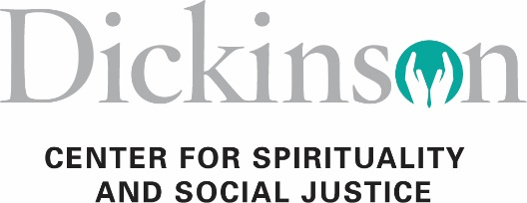

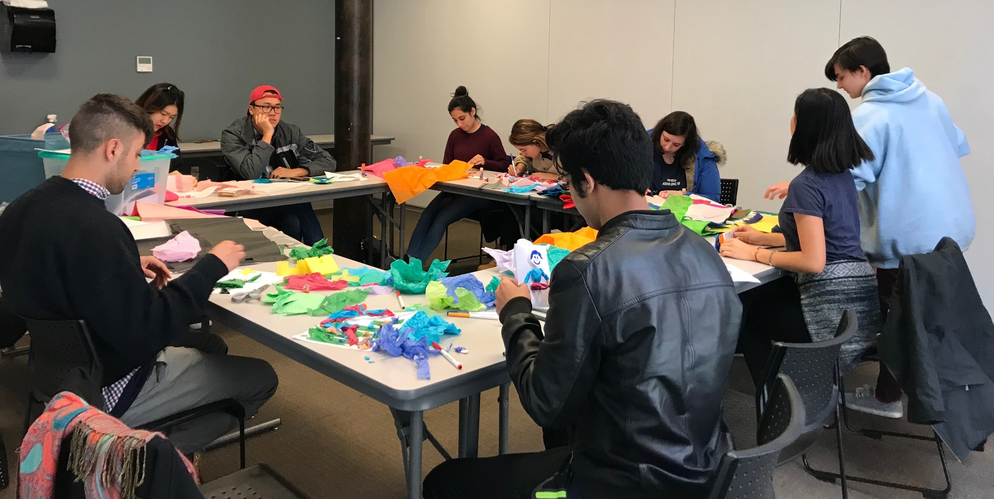
Interfaith Strategic Plan
January 2020

Contents
About Dickinson’s Interfaith Initiative………………………………………………………….2
Committee Members……………………………………………………………………….….3-4
The Mission of the Center for Spirituality & Social Justice (CSSJ)………………………….…5
Why is Interfaith Engagement Important?....................................................................................5
College Mission and Strategic Priorities………………………………………………………...6
Skills Needed for Interfaith Work and Leadership Development……………………………….6
Strategic Areas of Concern and Action Steps…………………………………………………...7
Strategic Area of Concern 1………………………………………………………….….7
Strategic Area of Concern 2…………………………………………………………...8-9
Strategic Area of Concern 3…………………………………………….…….….…10-11
Impact and Implementation…………………………………………………………………….11
Photos………………………………………………………………………………………......12

About Dickinson's Interfaith Initiative

In fall of 2018, the college brought Eboo Patel to lecture and do some training on interfaith literacy on campus; Patel is founder of Interfaith Youth Corps (IFYC). During that visit, Patel and other IFYC staff met with staff from the Division of Student Life, Vice President of Inclusivity and Institutional Effectiveness, interested faculty and students to begin to think about strategically increasing interfaith engagement at Dickinson. The formation of the Interfaith Strategic Planning Committee and now the Interfaith Advisory Council are outgrowths of those meetings.
The Interfaith Strategic Planning Committee was brought together in the Spring of 2019 by Donna Hughes, Director for the Center for Spirituality and Social Justice to work with a consultant from the Interfaith Youth Corps Office. Our Interfaith committee’s goal is to promote greater interfaith engagement at Dickinson. We see this goal as an expression of Dickinson’s commitments to inclusion, intercultural competence, and global citizenship.
The past few years have seen a rise in co-curricular programming at Dickinson College around religious, spiritual, and secular meaning-making. Between 2014-2019 we have hosted two interfaith service trips/year, facilitated numerous Exploring Religions programs, How to Be a Perfect Stranger with HR, Fall Faith Fest every year, A Good Life? Retreat, Spiritual direction for FAS and students, (still listing these) The college has sent students to the annual Interfaith Leadership Institute run by Chicago-based Interfaith Youth Core, has sent campus faculty and staff to the President’s Interfaith and Community Service Campus Challenge Conference, and has provided on-campus opportunities for staff , faculty and students to engage in dialogue and critical thinking about religious, spiritual, and secular meaning-making. Additionally, the Division of Student Affairs has sponsored webinars and other events to engage faculty, staff, and students in discussions centered on religion, spirituality, and secularity.

Committee Members

Kirk Anderson
Assistant Professor, Education Studies Department

Christine Baksi
Director of Media Relations

Carolyn Goode
Engagement Associate, Asbell Center for Jewish Life
Program Coordinator, Center for Spirituality and Social Justice

Becky Hammell
Associate Vice President of Student Leadership and Campus Engagement

Angie Harris
Associate Dean of Students

Donna Hughes
Director, Center for Spirituality and Social Justice

Amy McKiernan
Assistant Professor, Philosophy Department

Laura Megivern
Director of Community Engagement, Center for Civic Learning & Action

Angelica Mishra
Civic Learning Coordinator, Center for Civic Learning & Action
Program Coordinator, Center for Spirituality & Social Justice

Dennette Moul
Director of Human Resource Services

Committee Members (cont’d)

Greg Moyer
Assistant Vice President of Enrollment, Director of Administrative Recruitment

Sarah Niebler
Assistant Professor, Political Science Department

Sonja Paulson
Director of International Student and Scholar Services

Jodie Vann
Assistant Professor, Religion Department

Marley Weiner
Director, Asbell Center for Jewish Life

Megan Yost
Associate Professor, Psychology and Women’s, Gender, & Sexuality Studies Departments

The Mission of the Center for Spirituality and Social Justice (CSSJ)
The NEW Center for Spirituality and Social Justice guides, nurtures and enhances spiritual, religious and ethical life within the Dickinson College community. We are collectively committed to ensuring lively, thoughtful and supportive contexts for Dickinson students, faculty and staff to explore life's most pressing questions about who they are and want to become for the sake of the world.
To be effective global citizens our students require grounding in and a greater understanding of religious literacy and intercultural skills for engaging with diverse religions and worldviews. This work is not just the purview of a single campus office but requires a multi-faceted collaboration between divisions and an interdisciplinary mindset.
The Center for Spirituality and Social Justice seeks to develop a campus climate where people commit to understand, respect, and appreciate others' world views —their religious, spiritual, and secular/humanist meaning-making practices. We will help all in our community develop concrete skills to engage with differences among these various worldviews and faith traditions, to confront religious intolerance on campus and in the world, and to work together for the common good.
Why is Interfaith Engagement Important?
Interfaith engagement is the process of initiating awareness and action across differences in people's identities around religious, spiritual or secular meaning-making. Learning to engage across this difference is as important as learning to engage across categories of difference such as gender, race, ethnicity and sexual orientation.
In a workplace, society, and world characterized by a diversity of meaning-making perspectives, interfaith engagement equips students to collaborate more effectively with others. Other institutions of higher learning in the United States are implementing programming to help students, staff, and faculty engage with difference around religious, spiritual, or secular meaning-making. Interfaith Youth Core (IFYC), located in Chicago, is now assisting over 300 colleges and universities nationwide by providing resources and consultation services to develop strategies for interfaith engagement on campus. Here at Dickinson College, a planning committee of diverse stakeholders has been consulting with IFYC staff to prepare this strategic plan. Interfaith engagement through collaborative relationships builds capacity for strategic commitments and enhances a greater understanding and appreciation of pluralism.

College Mission and Strategic Priorities
Dickinson's mission implicitly supports interfaith engagement through a "useful, innovative and interdisciplinary education in the liberal arts and sciences to prepare students to lead rich and fulfilling live of engaged global leadership, working for the common good." An understanding of our own meaning making and that of others is paramount in developing global citizens and civic leaders who can work for the common good and cultivate community wherever they are. The college's strategic priorities stress its commitment to an "inclusive environment that acknowledges that we all belong to multiple cultures that influence our actions, beliefs and interactions." That commitment allows us to "value these cultural influences because they challenge our thinking and enrich our community." A promise to commit to an inclusive environment challenges us to "raise awareness, increase critical analysis" and become "socially responsible." We are challenged by this goal to strive for a foundation of "civility in all interactions."
Furthermore, for each of us, the inclusive environment provides support for our own identity development, "understanding about [our] own worldview and how that influences [our] actions." We learn to "recognize differences based on worldview," "seek openness to other ideas, behaviors and cultures" and perhaps most importantly by taking the risks that allow one to "develop greater openness" about self and those around us. We may even find it possible to 'revise our worldview" and take "action to promote equity on and off campus."
The college's mission and its strategic priorities link directly to the skillsets required of interfaith leaders and their ability to effect positive change in the world.

Skills Needed for Interfaith Work and Leadership Development

In his book "The Vision of Interfaith Leadership" Eboo Patel asserts that the attainment of pluralistic understanding and respect allows us to create communities which embrace difference. Even when experiencing disagreement and dissension, this respect and understanding of others' worldviews enables us to work towards agreement and consensus for the common good. Or as he puts it, "Pluralism is the energetic engagement of diversity toward a positive end."
As we build the bridge towards a vision of pluralism, benefits to the civic good occur. Patel calls out the development of interfaith skills and an understanding of pluralism as having impact in these areas: 1) Increased understanding and reduction of prejudice; 2) Strengthened social cohesion and reduction of chances for identity-based conflict; 3) Bridging of social capital and ability to address social problems; 4) Sustained continuity of identity communities and reduction of isolation and 5) Creations of binding narratives for diverse societies.
Strategic Areas of Concern and Action Steps

1 How can we overcome resistance to talking about religion and broaden the conversation to create spaces where people will talk about what matters most to them and others will listen?
Action Step | Person Accountable | Timeline
Create a diversity curriculum for faculty/staff with 1.0 and 2.0 versions-professional development Hi/Diff | - Dennette Moul HR | - Ongoing
“Faith And” series with students, faculty, and staff-over a meal with invitations Hi/Easy | - CSSJ interfaith interns | - Ongoing
Expand “A Good Life?” retreat with cohorts Hi/Diff | - Amy McKiernan/Donna Hughes | - Fall/Spring 2019-2020
Bring in speakers from multiple viewpoints (Clarke Forum) on topics through an interfaith lens, for example on end of life issues (Muslim, Jewish, Christian, etc.) Easy/Low | - Interfaith Interns | - Ongoing

2 How can we empower and support members of the campus community to be ambassadors for their traditions/worldviews, while encouraging curiosity and interest from others?

Action Step | Person Accountable | Timeline
Elaborate on Faith Zone training to address diff components of various faith traditions (i.e. dietary restrictions) and why they’re important to adherents/practitioners; include 1.0 and 2.0 level trainings Low/Easy | - CSSJ with FY Mentors, RAs, FY Seminar profs  - Departments  HR | - Basic 1.0: 2019  - Deeper 2.0: Will take a little longer. Can be implemented in 2020-2021  - Begin 2020
Partner with student-run faith groups for events: show commonalities among religions rather than focusing on differences (i.e. interfaith smoothie night). Include cultural components (i.e. “Festival of Lights”) Low/Easy | - Donna Hughes  - Marley Weiner  - Carolyn Goode  - WIND  - Jessee Vasold  - Student Senate | - Ongoing
Raise awareness of religious spaces on  campus Low/Easy | - Donna Hughes  - CASE  - Facilities  - The HUB | - Begin 2019  - Notes: Signage and knowledge put up/distributed to Student Life, tour guides, etc., to add to Orientation Curriculum, needs to be widely available
Improve sacred spaces on campus (washing station for Muslim students, more centralized) Low/Diff | - Donna Hughes  - Facilities | - Needs to be built into FY21 budget  - NOTES: Will take $$ and planning time. Possible washing station for Muslim student could be in bathroom across from small chapel in Allison Hall, would need to build proper washing equipment
Recognize/acknowledge religious traditions via celebrations. Work with Dining Services specifically. MORE DIVERSE Hi/Easy | - CSSJ  - Marley Weiner  - Carolyn Goode  - Errol Huffman  - Art and Music Departments | Food part implemented 2020  - Adding an art/music component may take a little longer  - NOTES: For holidays like Diwali and Chinese New Year
Distribute list of religious holidays to faculty during syllabus design time Low/Easy | - CSSJ  - Profs by word of mouth  - Angie Harris | - Begin 2019  - NOTES: Send to every department on campus  - Note that Profs should put something about this in their syllabi  - Have one or two points about how certain holidays are celebrated (like fasting) so profs are aware

3 How can we create more interdisciplinary opportunities to interweave religious/worldview diversity content with diverse majors and disciplines, and cultivate awareness of new and existing opportunities?

Action Step | Person Accountable | Timeline
Partnering with CCLA for a Mosaic Program/Interfaith trip w/religious/interfaith focus Hi/Easy | - Build champions amongst faculty  - Laura Megivern  - Team teaching | - NOTES: Explore diversity of religions  - Communities' experience, include religion in migration  - 20-21 options for courses/curricular
Clarke Forum/Summer study group for faculty across disciplines Hi/Diff | - Jodi Vann and Megan Yost  - Bring in more stakeholders  - Clarke Forum | - NOTES: 2020-2021  - A separate summer study group? Or with EACC or CE?  - Conversation about major, requirements, etc.  - Grant funding necessary  - Looking at interfaith ideas/common readings
PR/Webpage- inform people of opportunities, highlight diverse majors and disciplines (Interfaith & YouTube videos) Hi/Diff | - Have interfaith interns in CSSJ office produce content, have MarComm involved or oversee creation | - 2019-2020
President’s  Commission on Inclusivity broaden discussion to include interfaith Hi/Easy | - PCOI already there/Sarah Niebler in both groups  - Brenda Bretz | - NOTES: Report out climate survey results  - Diversity Requirement:  - Ask which courses already include interfaith/faith components  - Explicitly add to course descriptions

Impact and Implementation:
Hi/Diff: High Impact and Difficult to Implement
Hi/Easy: High Impact and Easy to Implement
Low/Easy: Low Impact and Easy to Implement
Low/Diff: Low Impact and Difficult to Implement
