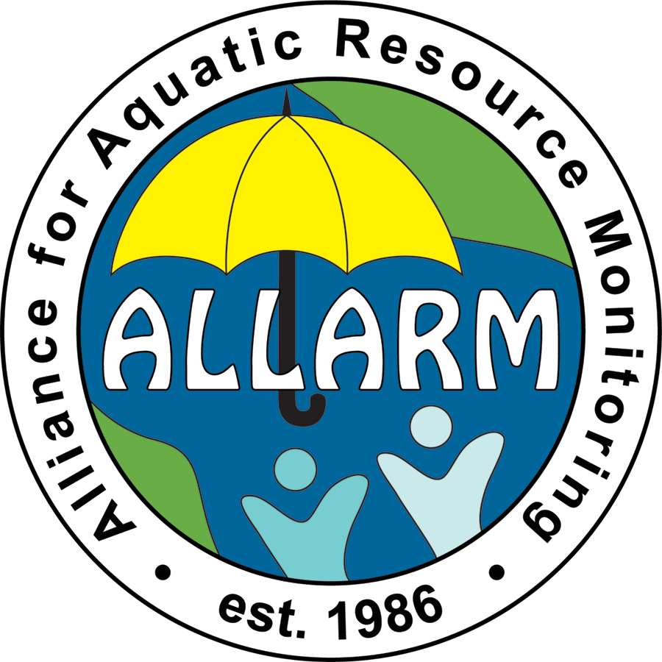
Alliance for Aquatic Resource Monitoring
Fall 2016 Staff Position Application

For more information and/or to submit an application - please visit the ALLARM office, Kaufman 124, or email vastine@dickinson.edu

DEADLINE TO APPLY: Monday April 4, 2016 by 12pm/noon.

Name: Email:
Campus/Cell Phone: Year of Graduation:
Cumulative GPA: Major(s): Are you federal work-study eligible? Yes No

Please review ALLARM’s web site for a sense of the opportunities available to students: http://j.mp/allarmjob

- How did you hear about the ALLARM position?
- Why are you interested in working at ALLARM?
- What is your interest in working with Pennsylvania communities?
- What do you think are key tools for doing community-based work?
- What experience, outside of coursework, have you had working with others collaboratively?
- What water quality issues are you aware of in your hometown or here in Pennsylvania?
- What other ALLARM relevant skills or experiences do you have? (e.g. public speaking, writing, etc.)
- What special interests do you have that would be relevant to work at ALLARM?
- Have you ever worked/volunteered with a non-profit or environmental group? If so please summarize briefly.
- Please list any Environmental Studies / Science or Sustainability courses you have taken:
- List campus activities:
- List community activities:
- Jobs Held (please provide a short summary):
- Computer Skills (hardware, software, etc.):
- Please list 2 references (professors, supervisors for on-campus or off-campus jobs, etc. include telephone number and email address).
- If you are a rising junior and are planning on studying abroad, please indicate what semesters you will be off campus.

