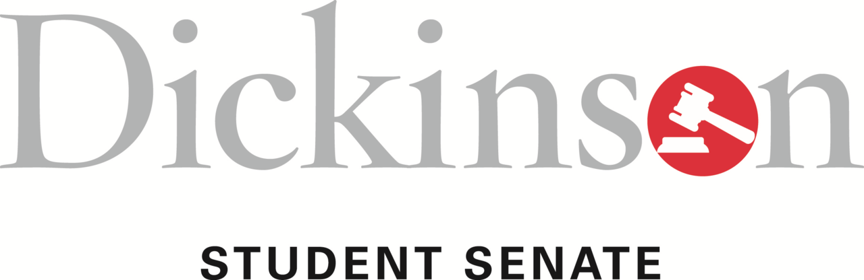

Minutes
Tuesday, November 5, 2013, at 6:30 p.m.
Denny 317

Call to Order
Student Senate met on Tuesday, November 5, 2013 and was called to order by President William Nelligan at 6:30 p.m. Members approved the minutes from the October 29, 2013 meeting.

Agenda Items

Committee Reports

Next week’s Senate meeting will be in the Social Hall and be followed by an informal meet and greet with constituents.

PAC has furthered the application for TEDx and is beginning to schedule A Contemporary Moment events starting next week. The first one will be with Professor Edlin.

Finance began to discuss possible Senate funding for Special Events.

CAC met with two possible new media organizations on campus.

ESLC has begun a discussion on retention rates, specifically in relation to First Year Seminars, Orientation, and Housing.

PnB discussed alumni relations and what the relationship between the College and its graduates looks like.

ITS discussed the Educause report and the new trends in technology services on campus. They are also working to amend their standing rules as an All-College committee. They are looking for constituent input.

APSC is discussing future curricular changes. They have also discussed the College’s assessment on all of the academic divisions. The D3 departments were recently assessed.

Student Life has discussing the different ways they can utilize Allison Hall. They are looking for further constituent research. They have also begun to work on more informal methods of student outreach.
Moderated caucus on Senate Advisory Committees

Emily Pryor ’14 moved for a moderated caucus to discuss the implementation of Senate Advisory committees over different aspects if the College such as the library, DPS, the dining hall, etc.

A primary focus would be establishing a food services advisory committee, as a majority of the Student Life complaints relate to food. Whether or not the committees have influence or just provide with us could be determined as necessary. Concern was also raised about the need for a facilities and maintenance advisory committee to foster student input. Concern was also raised about possible overlap and avoiding said overlap. The possibility of faculty input was also discussed. These committees will not be just Senators.

Callie Briscoe ’14 added that a member of the group being advised should be present to increase the influence of the groups.

Howard Keenan ’16 recommended that any advisory group discussions be published in a public format to raise awareness about the content of the discussions.

Ben West ’14 suggested that this absolutely falls under the Student Senate umbrella and that we should work to monopolize this idea and have a wide-ranging influence through these advisory committees. He concluded by saying that we have a lot of power in this area and we should work to ensure that our voice is hear.

Someone echoed the concern about overlap and added that we should not, “reinvent the wheel.”

Margaret Price ’14 suggested that faculty may be reluctant to provide input.

Tracy Wolf ’15 recommended we discuss establishing these advisory groups with advisory groups that already exist.

PAC Caucus

Nasir Ellis ’15 moved for a moderated caucus on the work of the Public Affairs Committee. He introduced A Contemporary moment, which focuses to expand departmental education outside of the syllabus and on current events

The program would not be a lecture style, but more of an informal discussion.

Nasir Ellis ’14 proposed a second moderated caucus about New York Times Table Talks, bringing up how we should go about setting up the discussion format for these talks that are a part of our New York Times Readership Program

Callie Briscoe ’14 recommended making the format like the language tables, where students can go, get their food, and have an informal discussion
Rachel Meyer ’15 suggested creating a trendy-New York environment and dividing the program by sections based on the different sections of the paper.

This also presents a unique way to utilize the Allison Hall. The idea started as a morning thing.

Tracy Wolfe ’15 brought up the concern about getting professors to attend these sessions.

Second reading of Class Events Funding resolution

Nick Toole ’14 moved for the second reading of the Class Events Funding resolution. The resolution only applies to this year.

The resolution passed unanimously.
Good of the Order
- Spring Break Service Trip applications are due November 15th.
- Next week, there will be a discussion about furniture on campus.
- Tours of Allison Hall are available.
- Follow Student Senate on various social media outlets.
- Apollo Night is next Thursday and tickets are on sale in The Underground.
- The library does not have a copy of President Durden’s book.

