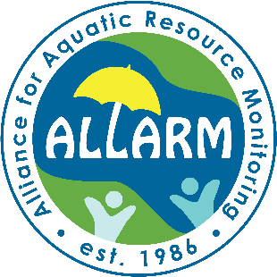Alliance for Aquatic Resource Monitoring  
FY 2025-2026 Staff Position Application  
For more information and/or to submit an application - please visit the ALLARM office, Kaufman 124, or email [vanfossl@dickinson.edu](mailto:vanfossl@dickinson.edu)DEADLINE TO APPLY: Sunday March 30, 11:59 PM EST

**Name:**

**Email:**

**Campus/Cell Phone:**

**Year of Graduation:**

**Cumulative GPA: Major(s):**   
**Are you federal work-study eligible? Yes No**

**Please review ALLARM’s website for a sense of the opportunities available to students:** [**http://j.mp/allarmjob**](http://j.mp/allarmjob)

1. How did you hear about the ALLARM position?
2. Why are you interested in working at ALLARM?
3. What is your interest in working with Pennsylvania communities?
4. What do you think are key tools for doing community-based work?
5. What experience, outside of coursework, have you had working with others collaboratively?
6. What water quality issues are you aware of in your hometown or here in Pennsylvania?
7. What other ALLARM relevant skills or experiences do you have? (e.g. public speaking, writing, Canva, Adobe Suite, etc.)
8. What special interests do you have that would be relevant to work at ALLARM?
9. Have you ever worked/volunteered with a non-profit or environmental group? If so, please summarize briefly.
10. Please list any Environmental Studies / Science or Sustainability courses you have taken:
11. List campus activities:
12. List community activities:
13. Jobs Held (please provide a short summary):
14. Computer Skills (hardware, software, etc.):
15. Please list 2 references (professors, supervisors for on-campus or off-campus jobs, etc. include telephone number and email address).
16. If you are a rising junior and are planning on studying abroad, please indicate what semesters you will be off campus.
17. Are you applying to start fall semester 2025 or are you interested in working both this summer and the fall semester (we do not hire for summer-only positions)?