YOUR “HOW TO…” INSTRUCTIONS
FOR THE FIRST-YEAR ADVISING
AND COURSE REGISTRATION

STEP 1
Carefully review all the information found on the Academic Advising and Course Selection tab of the Orientation web site.

Note: To review the course offerings prior to your conversation with an advisor,
choose the Browse Classes link in Step 8.

Be sure to request classes before 4:00 pm EDT, Wednesday, July 24, 2023.

STEP 2
Open your web browser and go to the Dickinson Gateway.

STEP 3
Enter your Dickinson Gateway username and password then click Login. (Your username and password are included in the letter which came in the mailing. If you do not remember or have lost your Gateway username or password, please contact the Helpdesk at helpdesk@dickinson.edu)

STEP 4
To enter your Fall 2024 courses, click on the Banner Self-Service tab.

STEP 5
Select the Student tab.

STEP 6
Select the Course Selection link.

STEP 7
Select the Course Request & Registration link.

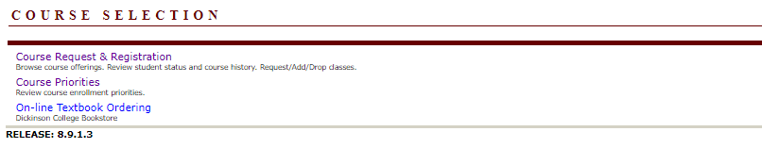

STEP 8
This will take you to the “Registration” screen. Choose “Register for Classes.”

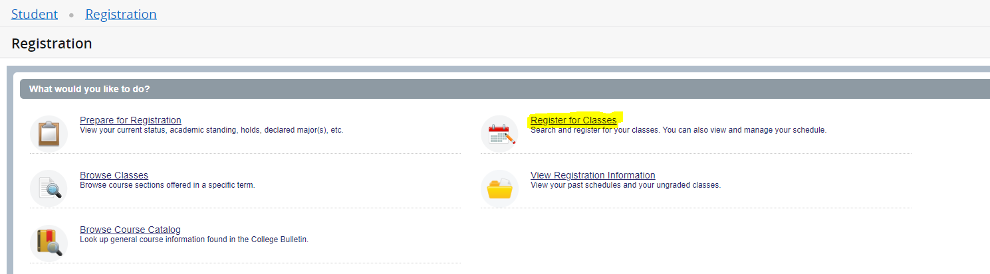

STEP 9
Select Fall 2024 from the drop-down menu.

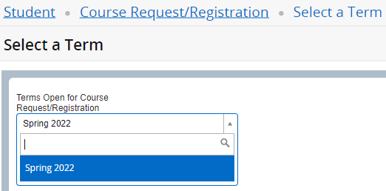

STEP 10
Once you select the term, you will be prompted to enter your Alternate PIN. The Alternate PIN begins with “AP” followed by 4 digits, and will be given to you by your advisor. Enter your Alternate PIN in the box then press the Continue button. Alternate PINs are case sensitive and all 6 characters must be entered, beginning with AP.

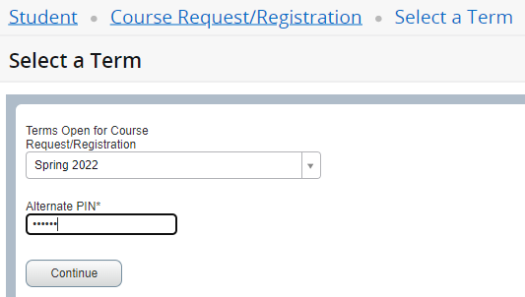

STEP 11
Enter your search criteria then press the Class Search button.
- You can search classes by entering one or more of the following criteria: a subject, course number, or keyword.
- When you click on the “subject” field, a dropdown list of choices will appear. You can scroll through the list to find the subject for which you are looking.

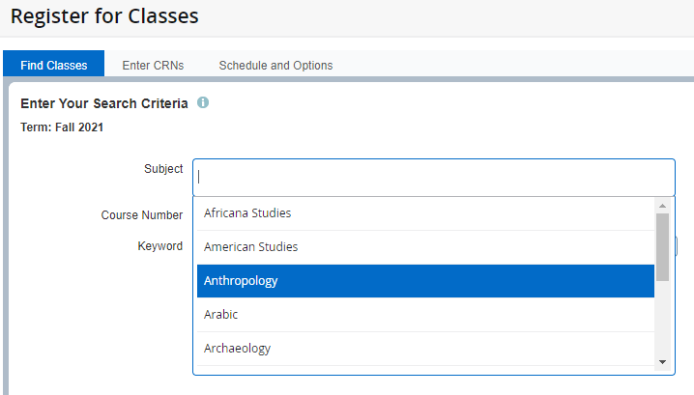

- You can also do an “advanced search” to search by other criteria
- To find courses appropriate for first-year students, click on “advanced search” select Appropriate
for First-Year from the Attribute list.

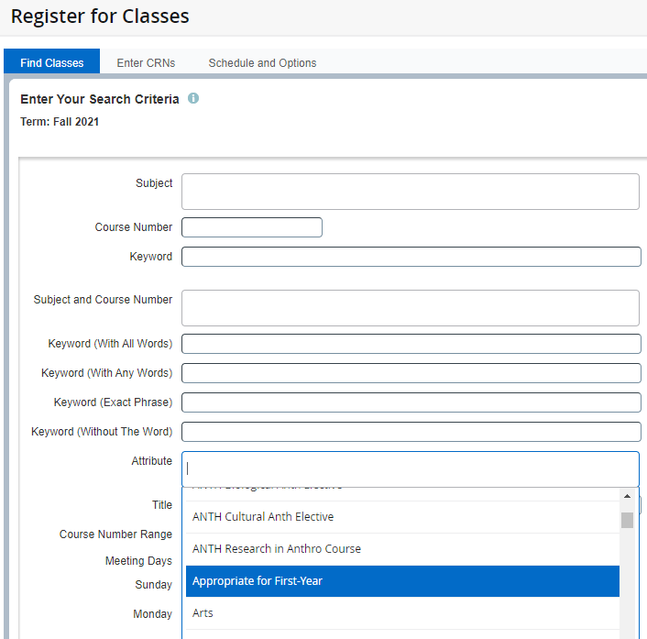

STEP 12
To add a course to your schedule, click on the “add” button on the right side of the screen.

This will place the course in the lower half of the screen as Pending.

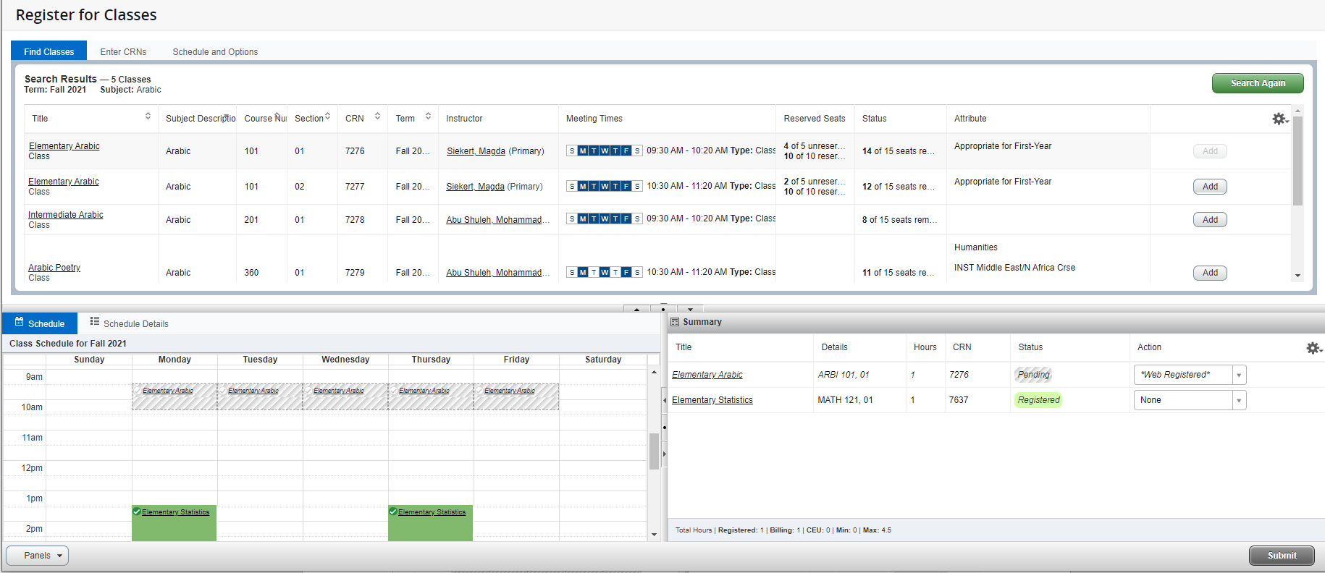

To finalize your request be sure to click the Submit button.

If your courses were successfully entered, they will show “Web Registered” in the Status column.

If you receive a Registration Error, it will appear at the top right of the screen as well as beside the course information at the bottom.
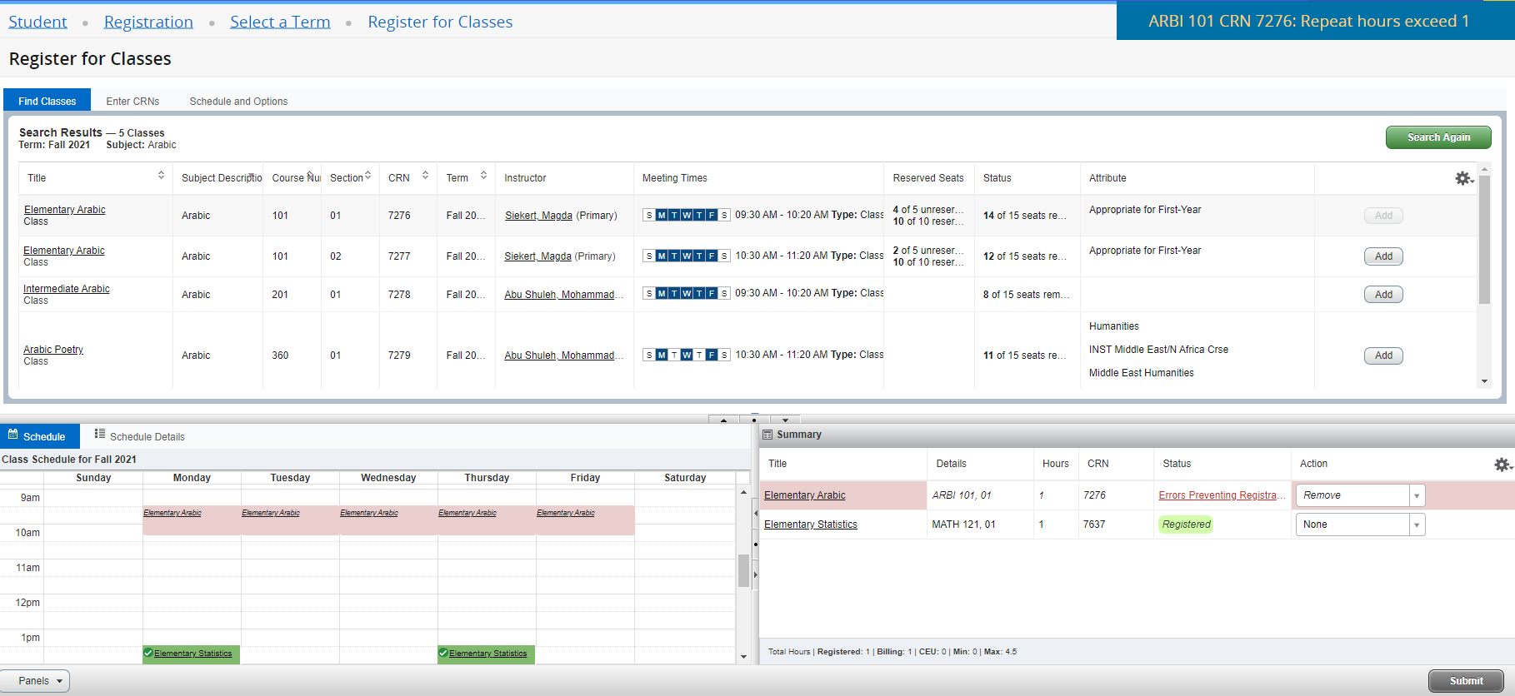

Make sure “Remove” is in the Action column and click the Submit button to remove the course with the error.

STEP 13
You can remove requested courses by using the dropdown menu found in the bottom right panel. Select Web Dropped from the Action column, then click the Submit button.

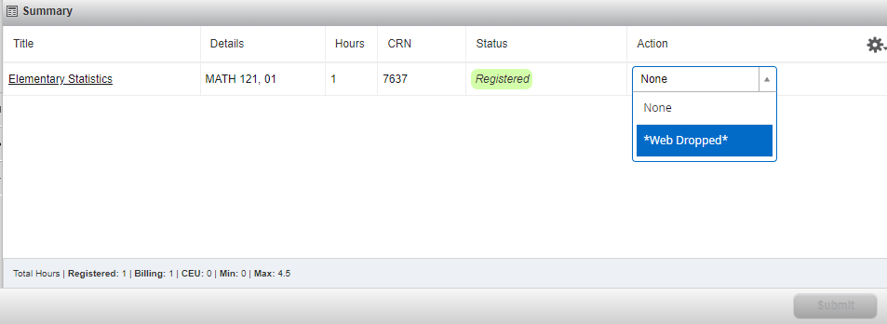

NOTES:
- Be sure to select three classes online. You are already registered for your First-Year Seminar – you do not need to re-enter that course.
- If you have any questions or concerns when going through the steps above, feel free to contact the Registrar’s Office for assistance – reg@dickinson.edu.

